2026

TokenCap Advisors LLC
1/1/2026
A Structured Risk Intelligence Framework: E&P
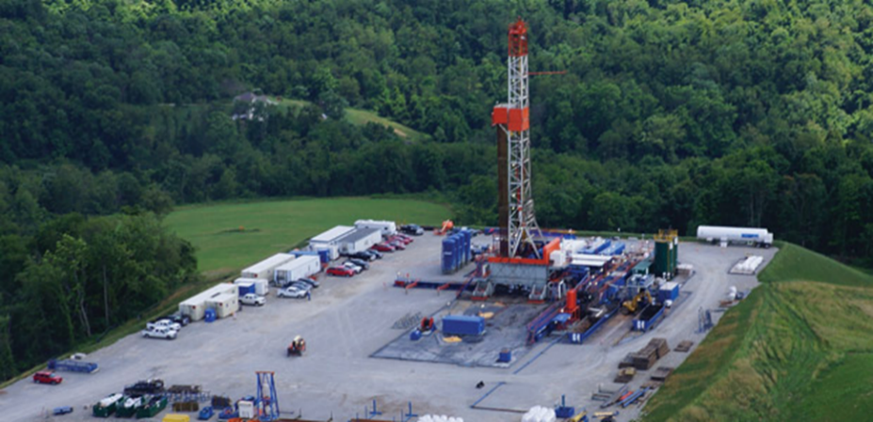
Contents
A Structured Risk Intelligence Framework for U.S. Upstream Oil & Gas Investments 2
Executive Summary 2
I. The Upstream Risk Continuum 3
II. The TCA Risk Intelligence Framework 4
III. Weighted, Stage-Sensitive Risk Modeling 5
IV. Composite Risk Score & Grading 5
V. Risk-Adjusted Return Alignment 5
VI. Institutional Use Cases 6
VII. Differentiation in the Market 6
VIII. Future Integration: Digital & Tokenized Assets 6
IX. Governance & Independence 7
X. Conclusion 7

A Structured Risk Intelligence Framework for U.S. Upstream Oil & Gas Investments

Executive Summary

TokenCap Advisors (TCA) is an independent research and risk intelligence firm specializing in the systematic evaluation, scoring, and ranking of upstream oil and natural gas projects in the United States.
The upstream energy sector presents a uniquely asymmetric risk-return profile. Projects range from high-risk virgin exploration prospects to stable producing wells generating predictable cash flow. Historically, investment decisions in this sector have relied heavily on operator reputation, fragmented geological interpretation, and non-standardized engineering assessments.

TCA introduces a structured, quantitative, stage-sensitive risk scoring methodology that enables capital providers to:

- Compare projects across the full exploration-to-production continuum
- Quantify geological, technical, regulatory, commercial, and infrastructure risk
- Align capital deployment with institutional risk tolerance
- Apply risk-adjusted return thresholds consistently
- Standardize upstream asset evaluation across portfolios

TCA functions analogously to a credit rating agency for upstream energy — translating subsurface uncertainty into investable clarity.

I. The Upstream Risk Continuum

Upstream oil and gas projects exist along a defined maturity spectrum:

Virgin Exploration → Prospect Definition → Permitted → Drilled & Tested → Development → Producing Wells

Risk declines as technical uncertainty is resolved and reserves transition from conceptual to proved producing.

II. Conceptual Risk Gradient

Below is TCA’s structured alignment of stage, primary risk driver, capital type, and commensurate return expectations.
Stage | Primary Risk Driver | Capital Type | Return Ranges Commensurate with Risk
Virgin Exploration | Geological uncertainty (hydrocarbon presence not proven) | High-risk equity / Wildcat capital | 35% – 70%+ IRR (binary outcomes; loss or multi-bagger)
Prospect Defined (Pre-Drill) | Subsurface probability & drilling execution | Venture energy capital / Family office | 25% – 45% IRR
Permitted / Drill-Ready | Execution risk & cost certainty | Opportunistic private equity | 20% – 35% IRR
Drilled & Tested (Discovery Stage) | Capital intensity & development scalability | Structured equity / Energy PE | 18% – 30% IRR
Development Program | Cost control, timing, operational scaling | Institutional private equity | 15% – 25% IRR
Producing Wells (PDP) | Commodity price & operating efficiency | Yield capital / Credit funds / Income investors | 8% – 18% IRR (often 10–15% target band)

III. The TCA Risk Intelligence Framework
TCA evaluates projects across five core risk domains:

1. Geological & Reservoir Risk (GR)
- Basin maturity
- Source rock viability
- Trap integrity
- Reservoir quality
- Hydrocarbon indicators
- Data density

This category dominates early-stage evaluation.

2. Technical & Execution Risk (TE)
- Drilling complexity
- Completion design
- Cost reliability (AFE confidence)
- Operator track record
- Supply chain exposure

This becomes critical in pre-drill and development stages.

3. Regulatory & Environmental Risk (RE)
- Permit status
- Environmental exposure
- Federal vs state jurisdiction
- Litigation risk

4. Commercial & Financial Risk (CF)
- Lease structure & royalty burden
- Capital stack stability
- Debt exposure
- Funding certainty
- Commodity hedge position

5. Infrastructure & Market Risk (IM)
- Takeaway capacity
- Processing availability
- Regional basis differential
- Operating cost sensitivity

IV. Weighted, Stage-Sensitive Risk Modeling

Not all risks carry equal importance at all stages.

For example:

Exploration Stage Weighting

- Geological Risk: 40%
- Technical Risk: 20%
- Regulatory Risk: 15%
- Commercial Risk: 15%
- Infrastructure Risk: 10%

Producing Stage Weighting

- Geological Risk: 5%
- Technical Risk: 20%
- Regulatory Risk: 15%
- Commercial Risk: 35%
- Infrastructure Risk: 25%

This dynamic weighting allows TCA to avoid static risk scoring distortions.

V. Composite Risk Score & Grading

Each project receives:
- A numerical composite risk score (1.0–5.0)
- A categorical grade:

Score Range | TCA Grade | Institutional Interpretation
1.0–1.9 | TCA-A | Stable, income-oriented
2.0–2.5 | TCA-B | Core energy allocation
2.6–3.2 | TCA-C | Opportunistic
3.3–4.0 | TCA-D | High-risk capital
>4.0 | TCA-S | Speculative

This enables portfolio construction across multiple risk bands.

V. Risk-Adjusted Return Alignment

TCA integrates risk scoring with required return thresholds:

Required IRR = Risk-Free Rate + (Composite Score × Risk Premium Multiplier)
Example:

Risk-Free Rate: 4%
Composite Score: 3.0
Risk Multiplier: 3%
Required IRR = 13%

This ensures capital pricing reflects structured risk rather than sentiment.

VI. Institutional Use Cases

TCA’s framework supports:

Private Equity Firms
- Screening upstream opportunities
- Portfolio risk balancing
- Exit valuation positioning

Family Offices
- Comparing exploration vs PDP cash-flow assets
- Managing commodity exposure risk

Credit Funds
- Underwriting reserve-based lending risk

Energy-Focused Funds
- Creating tiered fund strategies by TCA grade

VII. Differentiation in the Market

Traditional upstream evaluation relies on:
- Subjective geological narratives
- Operator-provided economics
- Non-standardized reserve reporting
TCA introduces:
- Structured scoring
- Quantifiable uncertainty metrics
- Cross-project comparability
- Defensible capital allocation methodology
TCA reduces cognitive bias in energy investing.

VIII. Future Integration: Digital & Tokenized Assets

The TCA framework is compatible with:
- Tokenized working interest offerings
- Blockchain-based reserve transparency
- On-chain yield products backed by producing wells
- Digital secondary markets for graded upstream assets
By standardizing risk evaluation, TCA creates a foundation for financial innovation in energy markets.

IX. Governance & Independence

To maintain institutional credibility, TCA:

- Operates independently from operators
- Discloses methodology transparently
- Maintains audit trails for scoring
- Applies standardized review protocols
- Separates research from capital deployment

X. Conclusion

Upstream energy investment is inherently complex due to subsurface uncertainty and commodity volatility.

TokenCap Advisors introduces a disciplined, institutional-grade framework that:

- Quantifies risk across the exploration-to-production lifecycle
- Aligns capital with structured return expectations
- Standardizes upstream project evaluation
- Enhances transparency in energy capital markets

TCA represents a modernization of upstream due diligence — transforming geological uncertainty into structured financial intelligence.

